

PROGRAMMING FOR AI

LAB MANUAL.

SUBMITTED TO:
MR.SAMRAIZ

SUBMITTED BY:
ABEER AWAIS
2023-BS-AI-022

Question # 1: Create a `BankAccount` class that represents a bank account. It should have attributes for account number, account holder name, and balance. Include methods to deposit, withdraw, and display balance. Ensure withdrawals cannot exceed the available balance.
CODE:
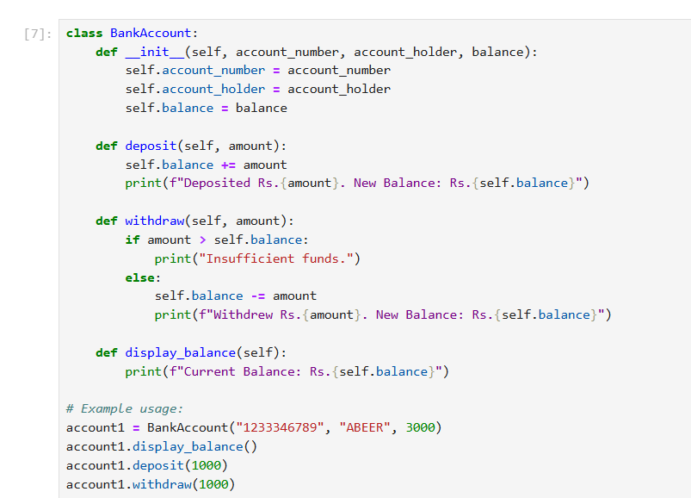

OUTPUT:
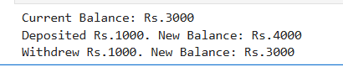

Question # 2: Design a `Book` class with attributes like title, author, ISBN, and availability status. Create a `Library` class that can add books, search for books by title/author, check out books, and return books. Track which books are currently available.
CODE:
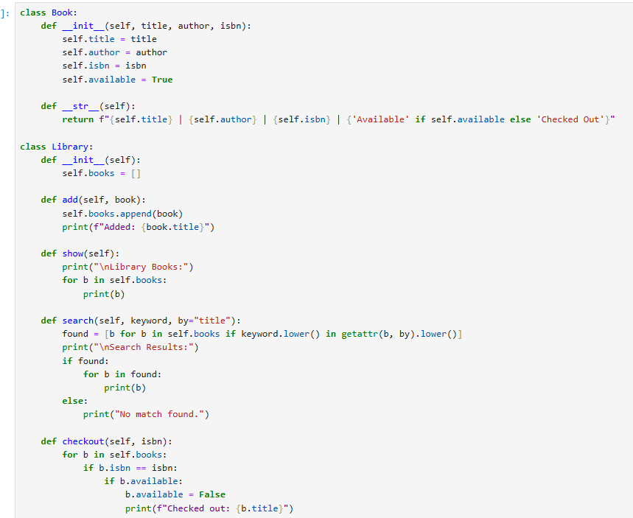
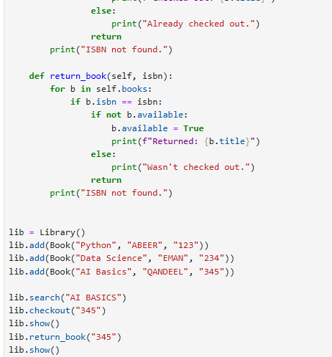
OUTPUT:
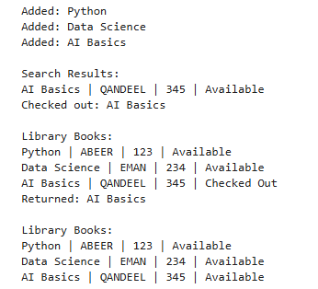
Question # 3: Create a `Student` class with attributes for student ID, name, and a list of grades. Implement methods to add grades, calculate average grade, and determine the letter grade (A, B, C, etc.). Add a method to display student information with their performance summary.
CODE:
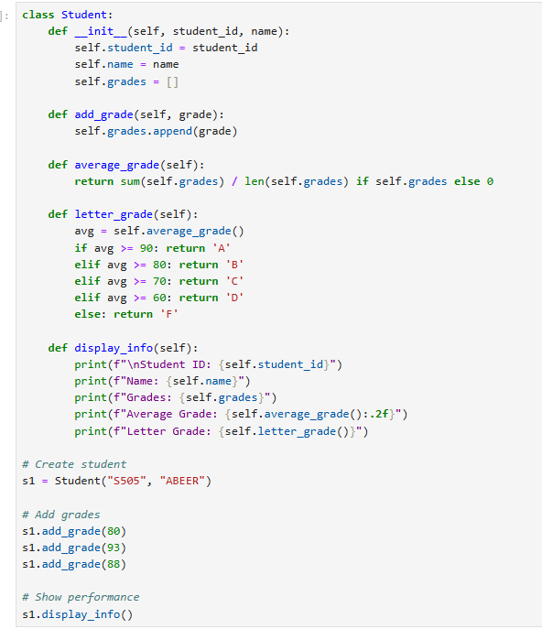

OUTPUT:
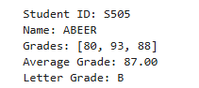
Question # 4: Design a `MenuItem` class for food items (name, price, category) and an `Order` class that can add multiple items, calculate total cost, apply discounts, and generate receipts. Include tax calculation functionality.
CODE:
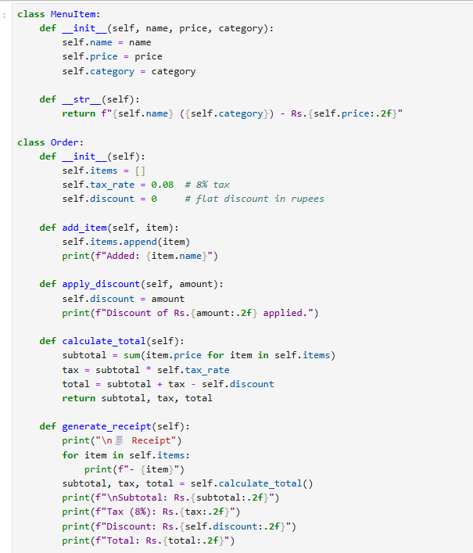
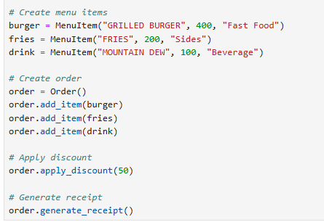

OUTPUT:
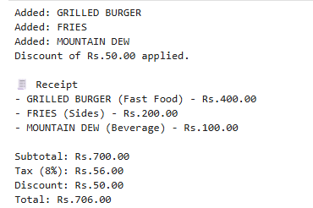

Question # 5: Create classes for `Vehicle` (base class) and derived classes `Car`, `Motorcycle`, and `Truck`. Each vehicle should have attributes like license plate, model, rental price per day, and availability. Implement a system to rent vehicles and calculate rental costs.
Code:
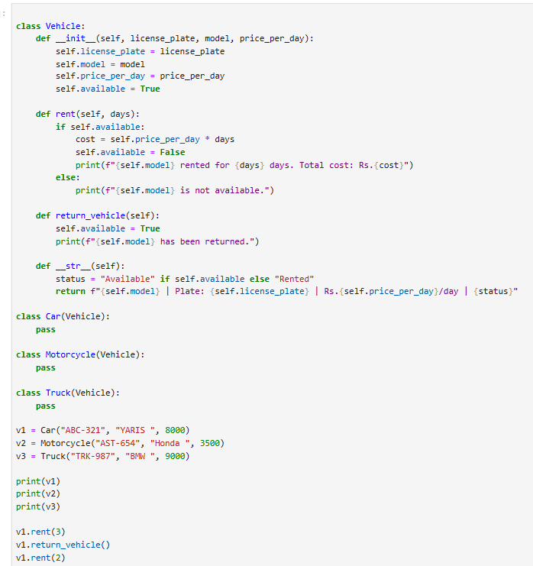

Output:
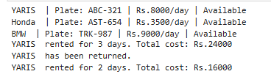
Question # 6: Design an `Employee` class with attributes for employee ID, name, position, and salary. Create methods to calculate monthly salary, annual salary, and apply raises. Include functionality to track employee details and employment duration.
CODE:
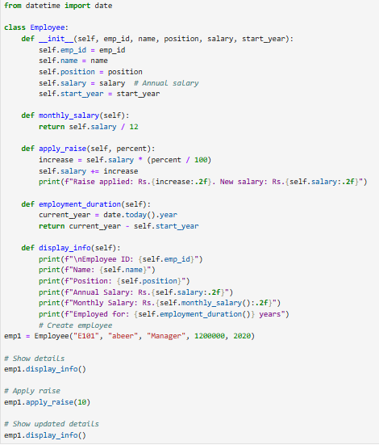

OUTPUT:
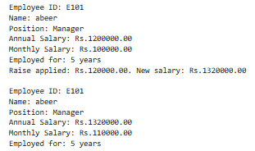

Question # 7: Create a `Product` class with attributes for product ID, name, price, and stock quantity. Design a `ShoppingCart` class that can add products, remove products, calculate total cost, and handle checkout process while updating inventory.
CODE:
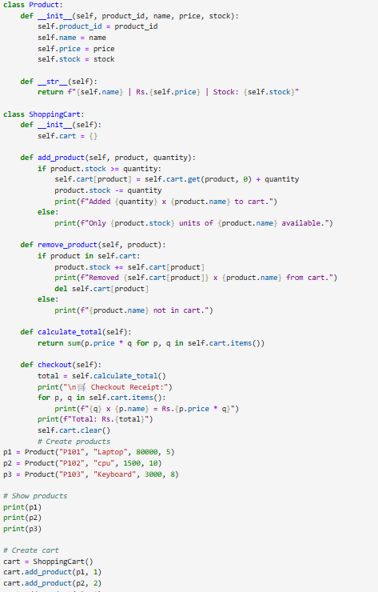
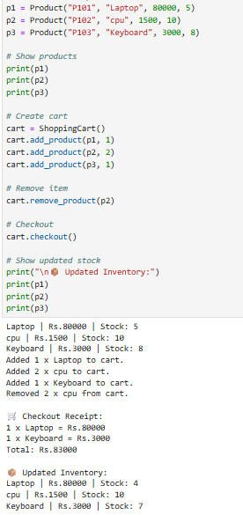

Question # 8: Design a `Patient` class to store patient information (ID, name, age, medical history) and an `Appointment` class to manage doctor appointments. Include functionality to schedule, cancel, and view appointments.
CODE:
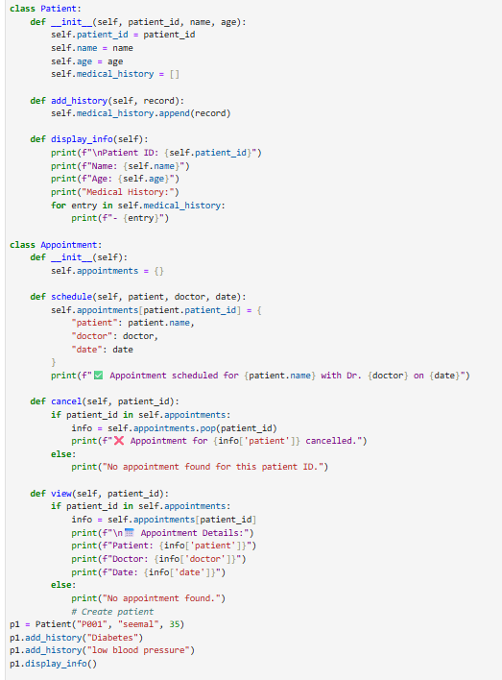

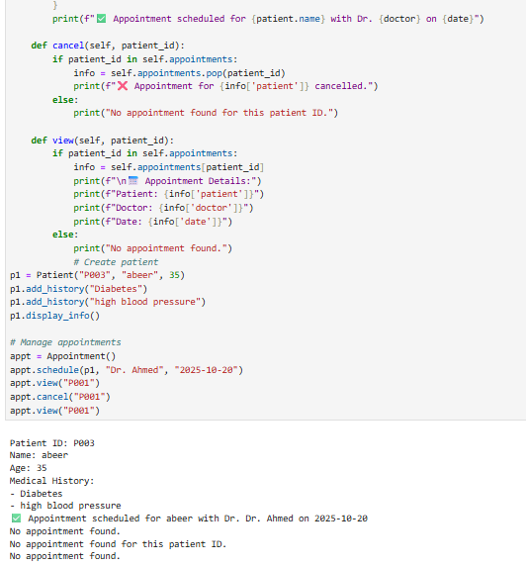

Question # 9: Create a `User` class for a social media platform with attributes for username, email, friends list, and posts. Implement methods to add friends, create posts, and display user timeline. Include privacy settings for posts.
Code:
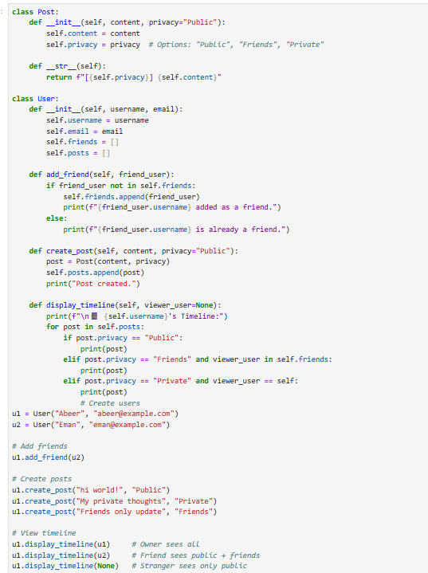
Output:
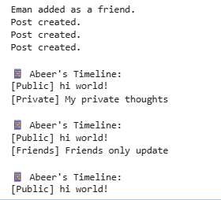

Question # 10: Design a `Room` class with room number, type (single/double/suite), price, and availability. Create a `Booking` class to handle room reservations, check-in/check-out dates, and calculate total stay cost.
CODE:
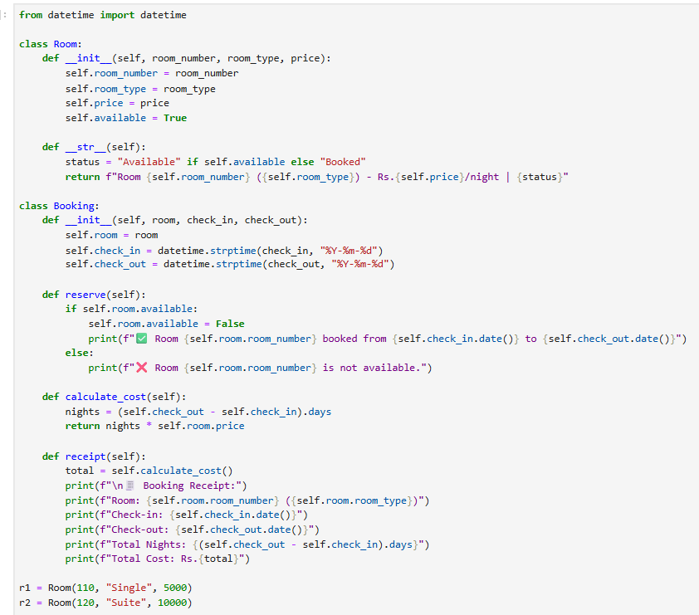

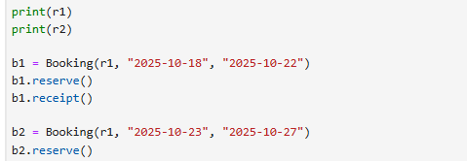

Output:
